Letter template – clients ready for tech upgrade

Our gift to you
Dear <customer name>,
Hearing well can have a positive influence on so many aspects of your life. Not only does hearing well help you to understand the world around you, it’s linked to a greater state of social-emotional, cognitive and physical well-being. Your well-being is always top of mind in our practice and it’s our mission to make sure you’re connected to the benefits of hearing well.
Since your last fitting, there has been exciting hearing technology advancements and we’d like to introduce you to the new Phonak Audéo LumityTM.
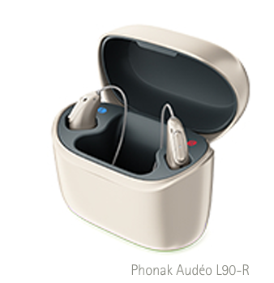
With unique SmartSpeech™ Technology, Audéo Lumity improves speech understanding¹ and helps you to enjoy conversations in any challenging listening situation.
Features also include:
• Universal connectivity to iOS®, Android™ and just about any Bluetooth® device, including smartphones, smart TVs and more
• Tap Control for easy access to Bluetooth functions
• Health data tracking
• Fully rechargeable, no more batteries
Test drive our latest hearing aid and let your conversations shine this festive season with family and friends.
During November and December, we are providing free hearing checks and the chance to trial our latest hearing aid, Audéo Lumity, obligation-free for 30 days.
Hear conversations and sounds in the comfort of your own surroundings to truly experience the hearing benefits this amazing technology creates.
We look forward to welcoming you back to help you find the best hearing solution for your needs. Call us to today to book in your free hearing assessment and experience Audéo Lumity today!

Kind regards,

Contact name
Clinic name
Phone and email contact details
1. Appleton, J. (2020) AutoSense OS 4.0 - significantly less listening effort and preferred for speech intelligibility. Phonak Field Study News retrieved from www.phonakpro.com/evidence, accessed August, 2022.

